**Sales App (Version-1):**

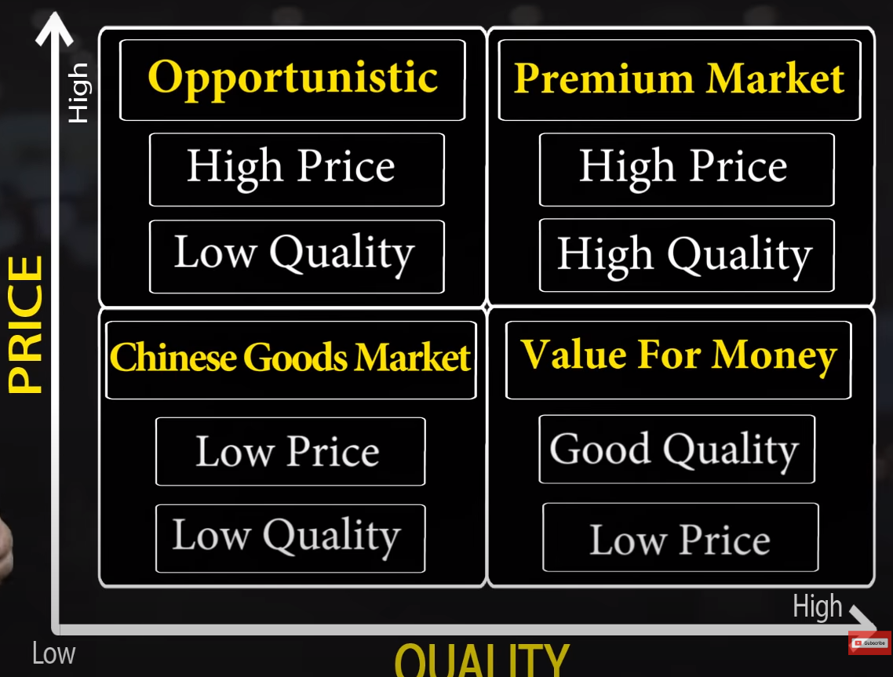

# Take input for price and quality (We sell software Apps)

price = float(input("Enter the price of the app: "))

quality = float(input("Enter the quality of the app: "))

# Determine the quadrant

if price > 0 and quality > 0:

    if price > 50 and quality < 50:

        quadrant = "Quadrant 1 - Opportunistic Market"

    elif price > 50 and quality >= 50:

        quadrant = "Quadrant 2 - Premium Market"

    elif price <= 50 and quality < 50:

        quadrant = "Quadrant 3 - Chinese Goods Market"

    elif price <= 50 and quality >= 50:

        quadrant = "Quadrant 4 - Value for Money Market"

else:

    quadrant = "Invalid input. Please enter positive values for price and quality."

# Print the quadrant

print("The app falls into:", quadrant)